**EXPERIMENT 2**

**CDS(LAB)**

**Name: Stuti Sehgal**

**Sap Id: 500107063**

**Batch :2(NH)**

**AIM: Working with Docker (Basic Commands)**

**Steps to Complete:**

1. Search a Redis image on DockerHub

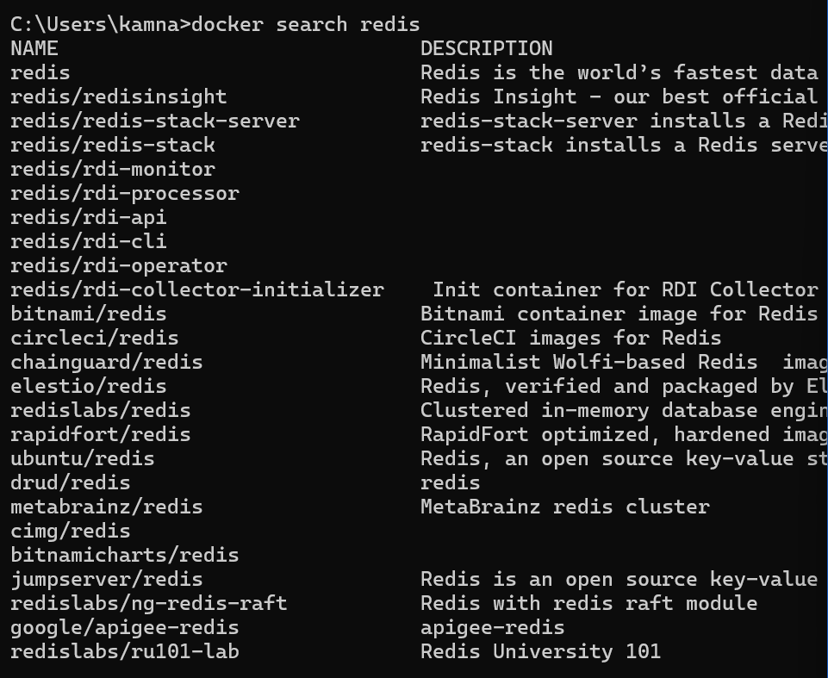

1. Run Docker Container of Redis Image in background

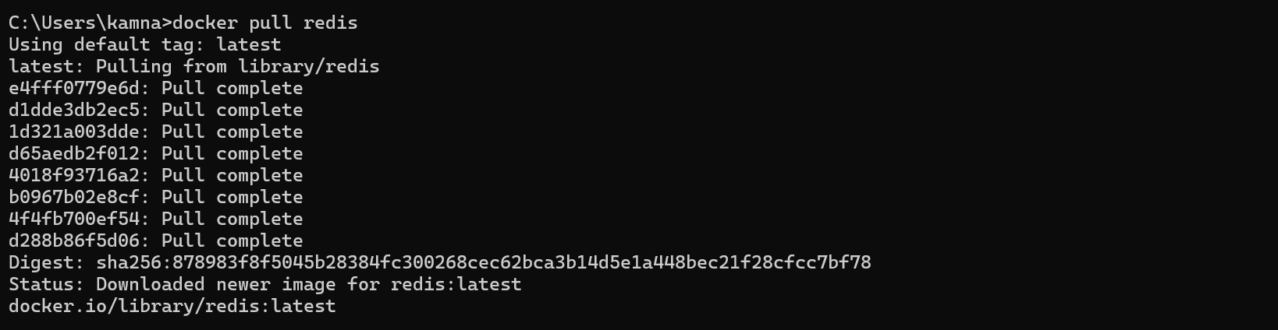

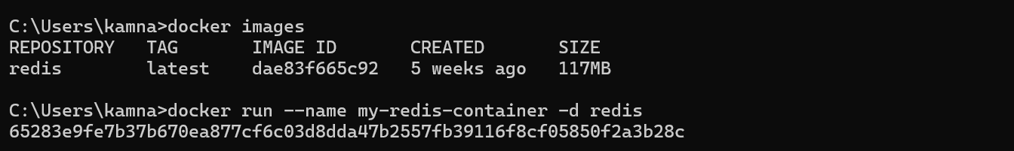

1. Run Docker PS and Docker PS –a

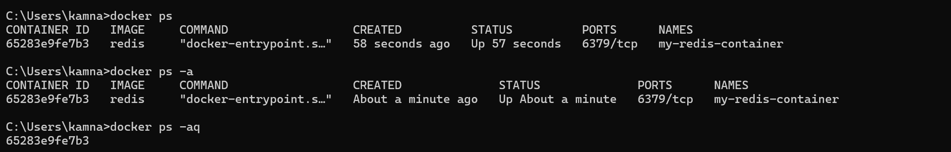

1. Run Docker Container and take its console

